July 28 2022

SLASH FILM FESTIVAL: FIRST MOVIES, ARTWORK, TRAILER
Sept 22 through October 2, 2022
Filmcasino | Metro Kinokulturhaus | Gartenbaukino

FOR IMMEDIATE RELEASE
If you suffer from triskaidekaphobia and are thus afraid of the number 13, you should avoid this year’s edition of SLASH at all costs. Because that is how old Vienna’s festival of fantastical film turns this autumn. In the spirit of SLASH, we interpret the diabolical number as a good omen and really “party down,” as is customary when reaching puberty. From trashy body-fluid flicks to politically ambitious eye-openers and explosive superhero blockbusters—eclectically-minded film buffs will surely get their due.
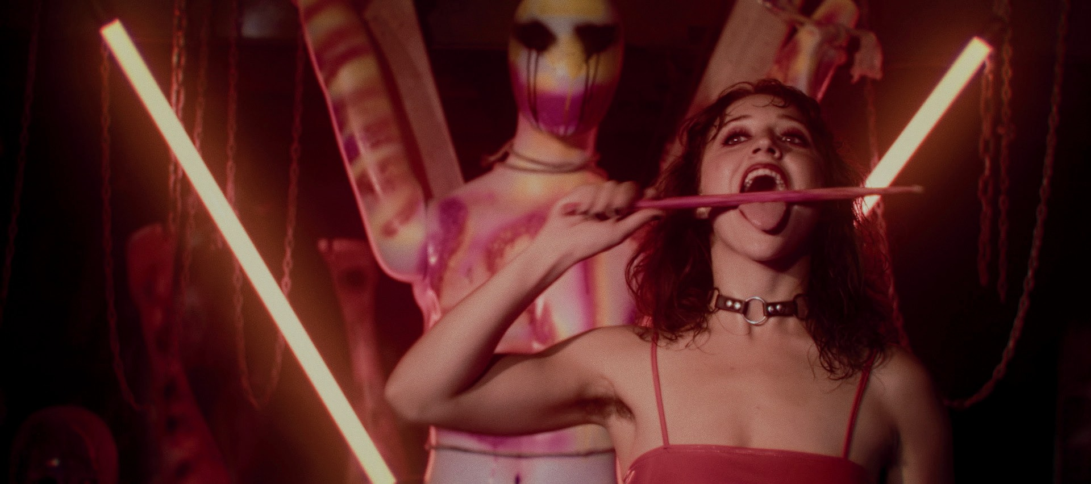

“Around the world in 80-ish films” might be the motto of this year’s SLASH Film Festival with its geographically diverse lineup. Not only are we serving supernatural fare from the Far East with Taiwanese found-footage sho- cker INCANTATION by Kevin Ko, we’re also letting a pretty hard Latin and South American wind blow through the SLASH venues with PUSSYCAKE and HUESERA. While Pablo Parès crams a selection of leaking bodily fluids down our throats, HUESERA by Michelle Garza Cervera strikes a decidedly subtler note in its exploration of a subject that, nonetheless, has become a staple of horror cinema: pregnancy.

And we’ll have come full circle—around the world, that is—with two highlights of contemporary African genre cinema, both of which premiered at the 2021 tiff (Toronto International Film Festival). In SALOUM, Congolese director Jean Luc Herbulot accomplished an astonishing mix of fantasy, western, and crime story, while the South African thriller drama GOOD MADAM presents the second work of a female director in this year’s line-up, Jenna Cato Bass.

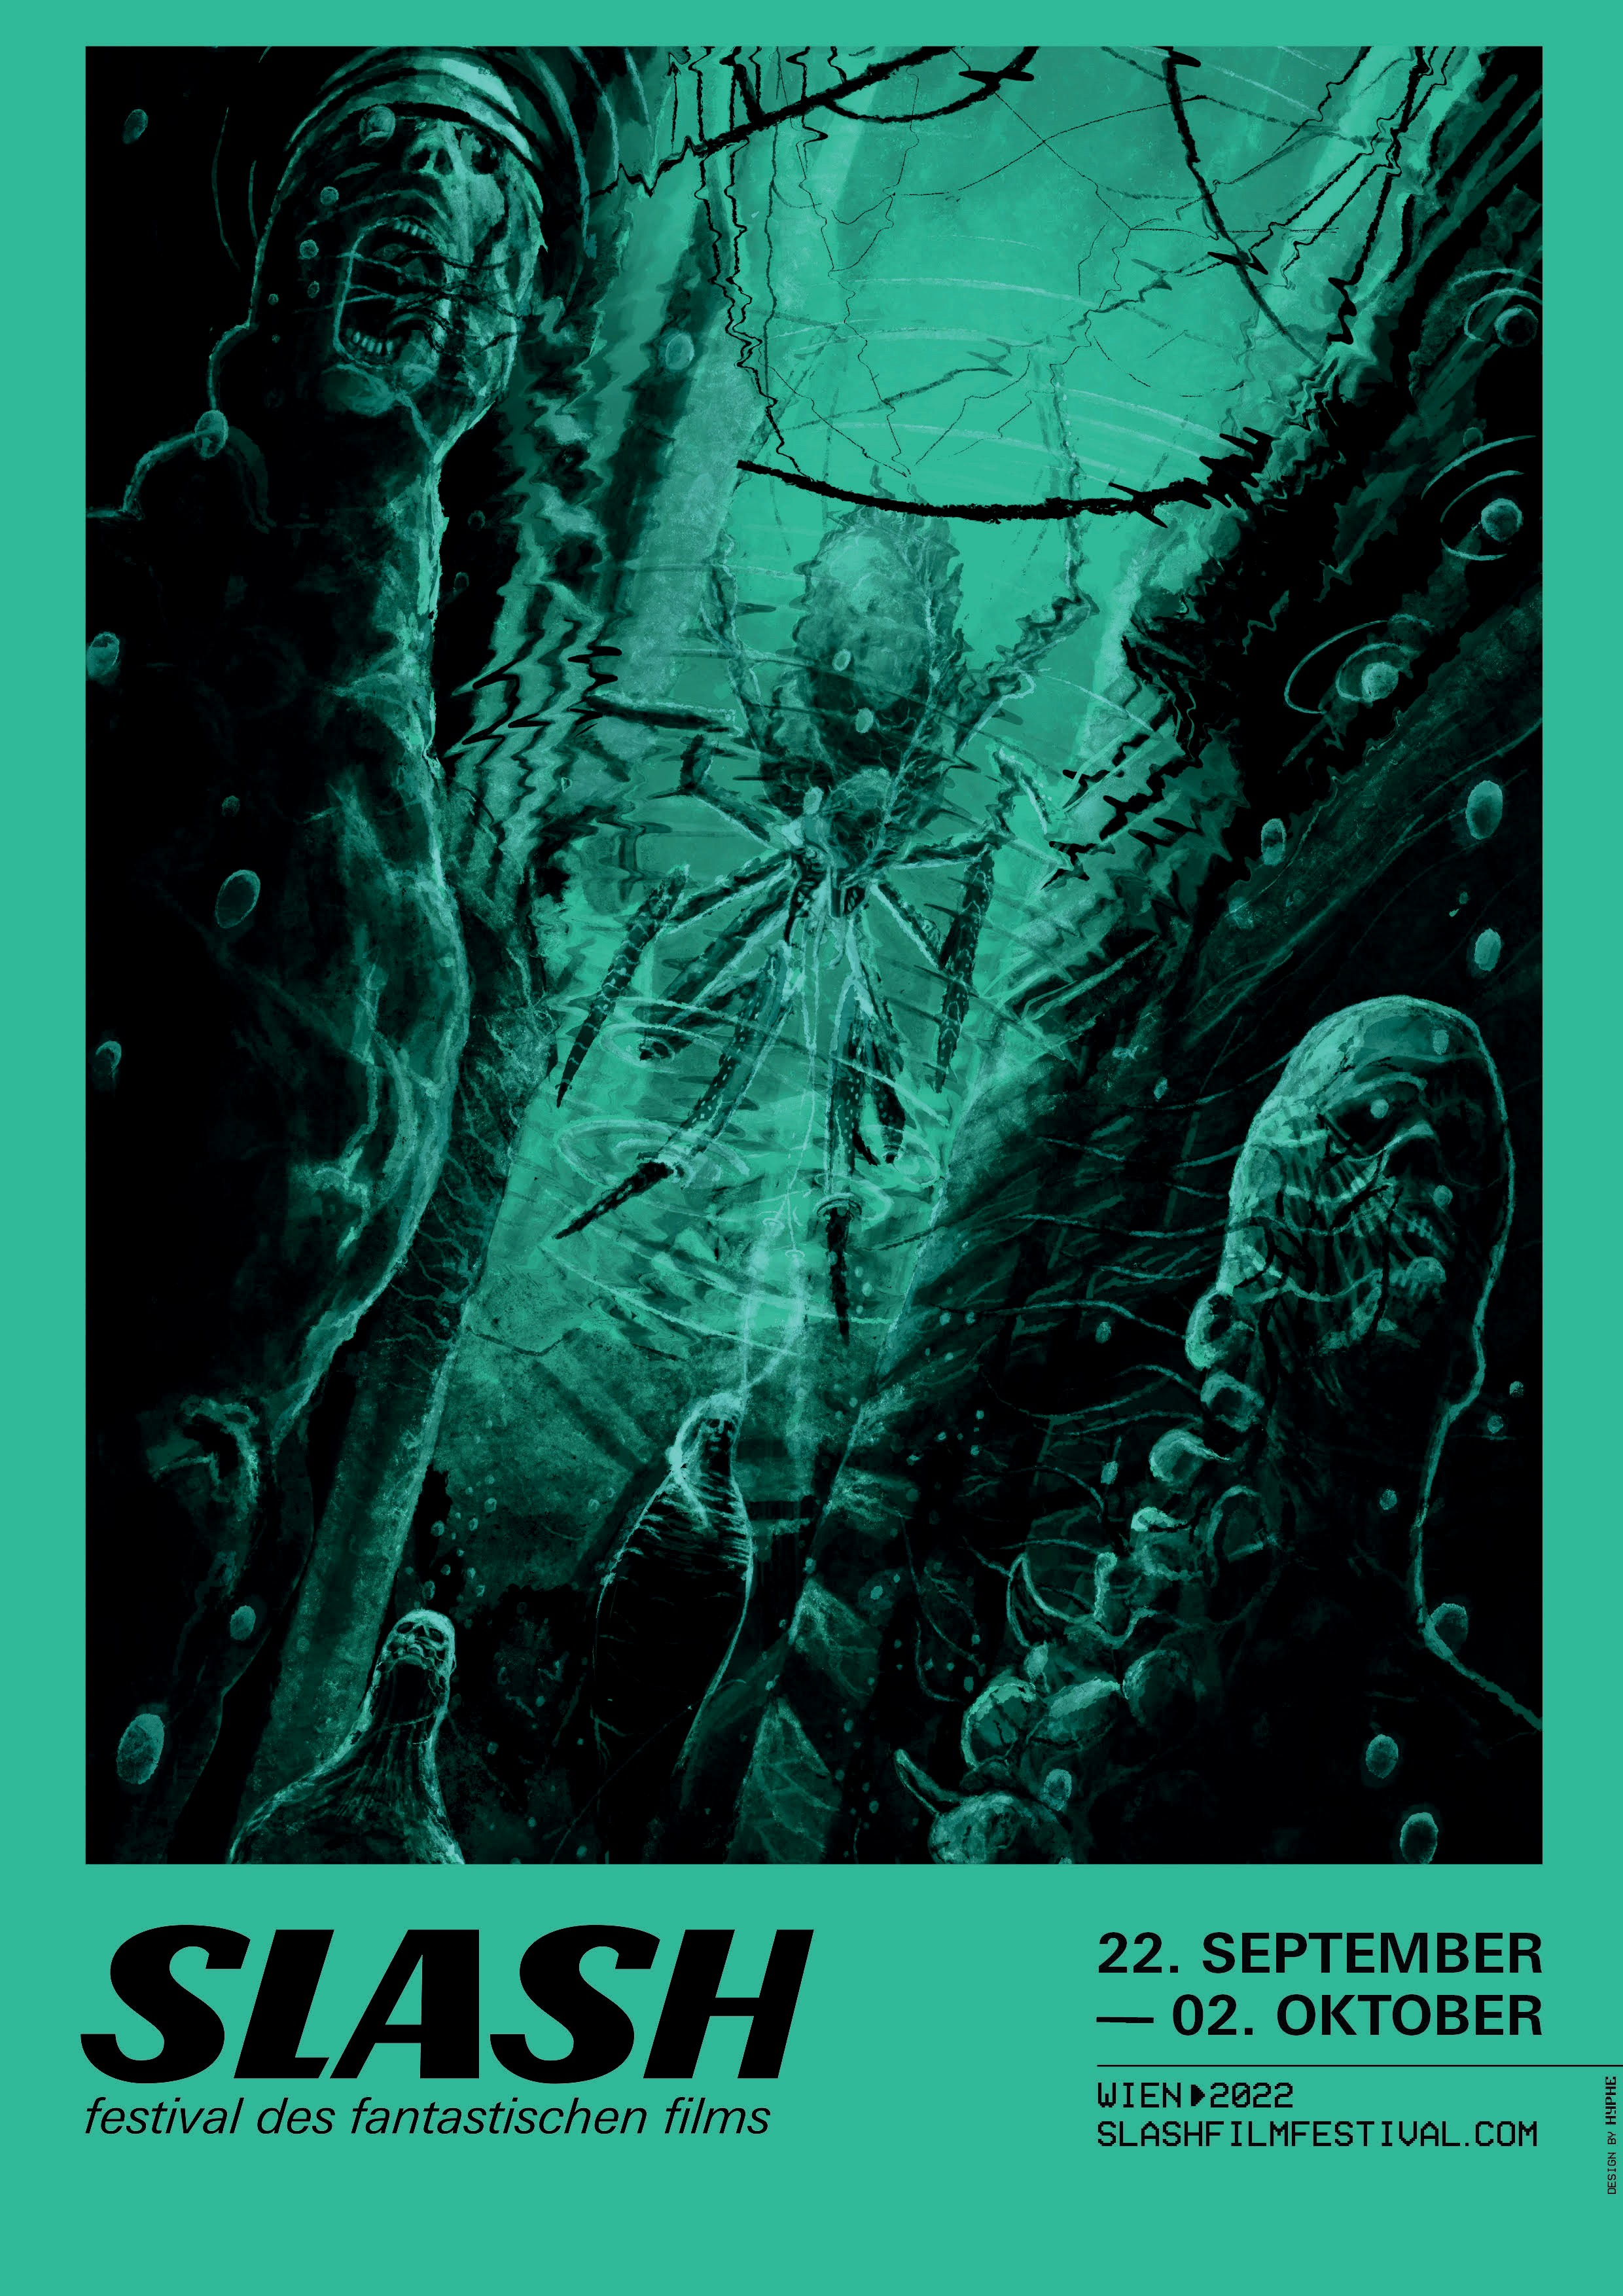
Also affecting the entire globe is any situation—as illustrated in this year’s festi- val artwork by the Viennese advertising agency HYPHE
—in which nature seeks revenge against its punisher, i.e., us. When the ground starts rumbling, global tem- peratures spike to unbeara- ble highs, and our failures are reflected in the surfaces of ever-rising oceans, we are facing forces for which we are no match. For their breathtaking design, Elias Fleischer, Franz Mühringer, and Michael Winiecki took inspiration from movies like THE HOST, GODZILLA, ALIEN, THE THING, and IN- VASION OF THE BODY
SNATCHERS, the gaming
series HALF-LIFE as well as the all-round prophetic writings of H. P. Lovecraft.

We are particularly proud of this year’s festival trailer, which was spawned by a collaboration between HYPHE and Fleischwolf Kollektiv and ties in thematically with the artwork: In green hues and underwater aesthetics, director Michael Winiecki and Art Director Elias Fleischer unsettle us with apocalyptic images that are amplified by erratic scribble animations and whirring rock sounds. Watch the disquieting feast for eyes and ears here!

In less than two months, it’s go-time again: Vienna’s Filmcasino at Margaretenstraße, Metro Kinokulturhaus, and Gartenbaukino at Parkring will let us partake in a most exquisite St. Vitus Dance. In the coming weeks we will announce the subject of this year’s SLASH retrospective, the ticket presale date, and a splendidly eccentric satellite program as well as, of course, the list of invited guests.

FILM SYNOPSES

INCANTATION

TW 2022
Director: Kevin Ko
Cast: Tsai Hsuan-yen, Huang Sin-ting, Kao Ying-hsuan, Sean Lin, RQ
The movie opens with Ronan looking into the camera, chanting an incantation, and asking the audience to join in. It’s supposed to bless her little daughter and lift the spell the girl has been under ever since Ronan took a trip with friends into the remote Chinese province of Yunnan six years ago to film a mysterious ritual. Kevin Ko’s found- footage fright fest INCANTATION proves once again that Taiwanese horror cinema is experiencing an impressive renaissance. In his home country, it became the most successful film of the year (so far). Will you dare to chant along?

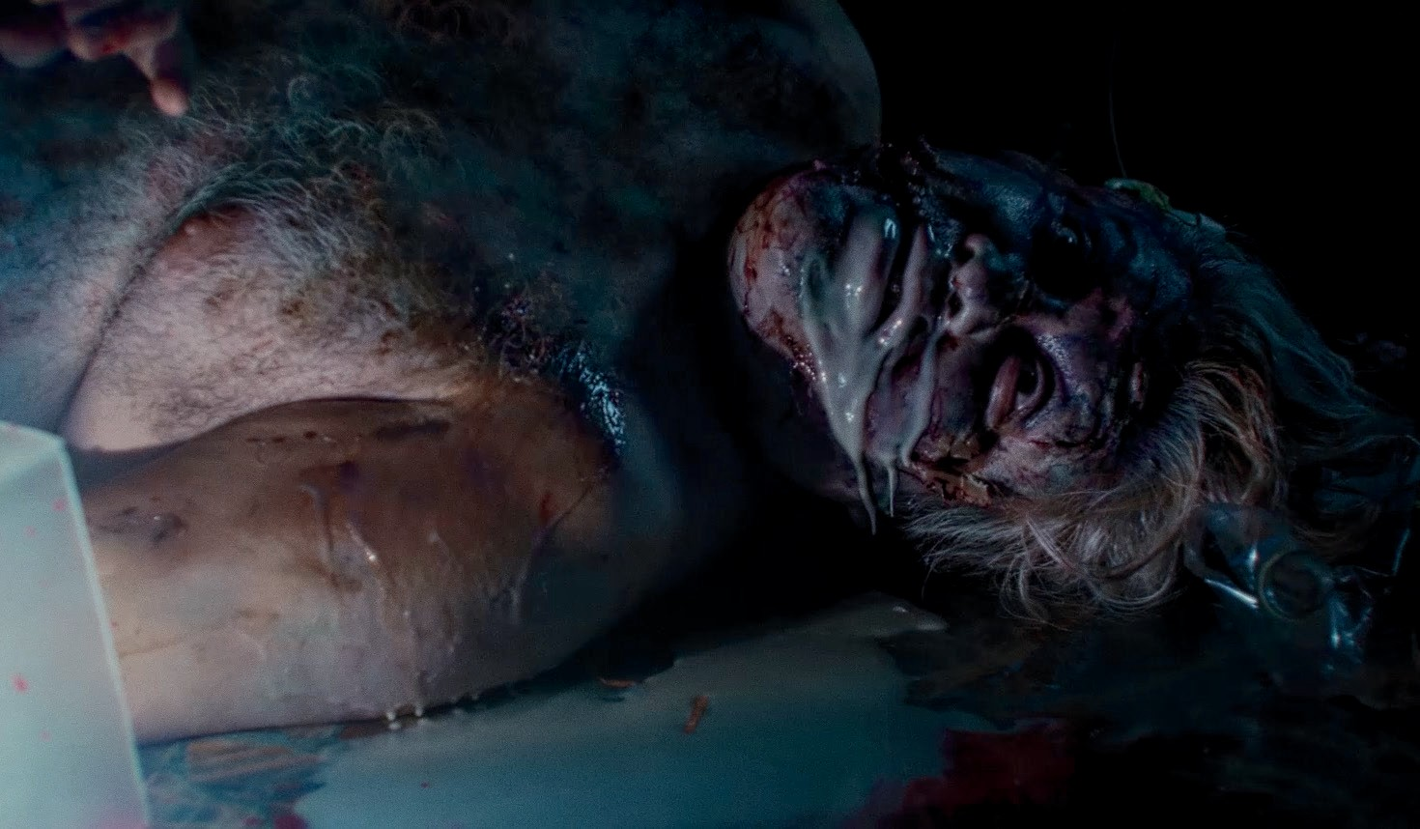

PUSSYCAKE

AR 2021
Director: Pablo Parés
Cast: Macarena Suárez, Aldana Ruberto, Flor Moreno, Sofia Rossi
The all-girl rock band Pussycake shreds, sings, and screams its way through dive bars. A gig in a coastal town, with some major-label music producers present, may be the big breakthrough. But on their arrival, the joint is closed and deserted. Instead, the hard-assed rockers are being attacked by projectile-vomiting zombies and must fend for their lives. The Argentinian splatter whiz Pablo Parés infuses this sprightly little trip with gallons of blood, mucus, and guts—PUSSYCAKE seems like an expulsion from the B-movie heyday and a cruise back to the 1980s. Fantastically phantasmagorical!

HUESERA

MX | PE 2022
Director: Michelle Garza Cervera
Cast: Alfonso Dosal, Sonia Couoh, Martha Claudia Moreno, Aida López
Valeria and Raúl have been trying for a long time to have a baby. Finally, the young woman gets pregnant—only to be afflicted by gruesome visions shortly thereafter. The huesera, a “bone woman” from Mexican mythology, seems to haunt and hunt the couple, and gaining ground. Michelle Garza Cervera’s outstanding feature debut is a bone-chilling horror drama with folkloric undercurrents, in which pregnancy itself is likened to a curse. Intense acting and excellent photography are further proof that the director is a significant new talent in Latin American genre cinema.

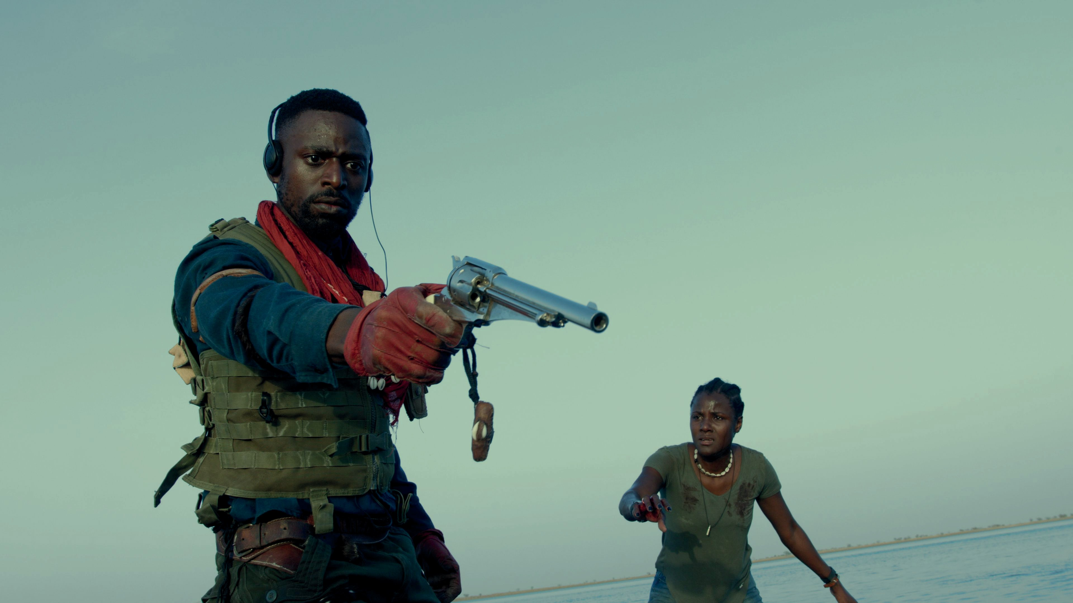

SALOUM

SN 2021
Director: Jean Luc Herbulot
Cast: Yann Gael, Evelyne Ily, Bruno Henry, Roger Sallah, Mentor Ba
Valeria and Raúl have been trying for a long time to have a baby. Finally, the young woman gets pregnant—only to be afflicted by gruesome visions shortly thereafter. The huesera, a “bone woman” from Mexican mythology, seems to haunt and hunt the couple, and gaining ground. Michelle Garza Cervera’s outstanding feature debut is a bone-chilling horror drama with folkloric undercurrents, in which pregnancy itself is likened to a curse. Intense acting and excellent photography are further proof that the director is a significant new talent in Latin American genre cinema.

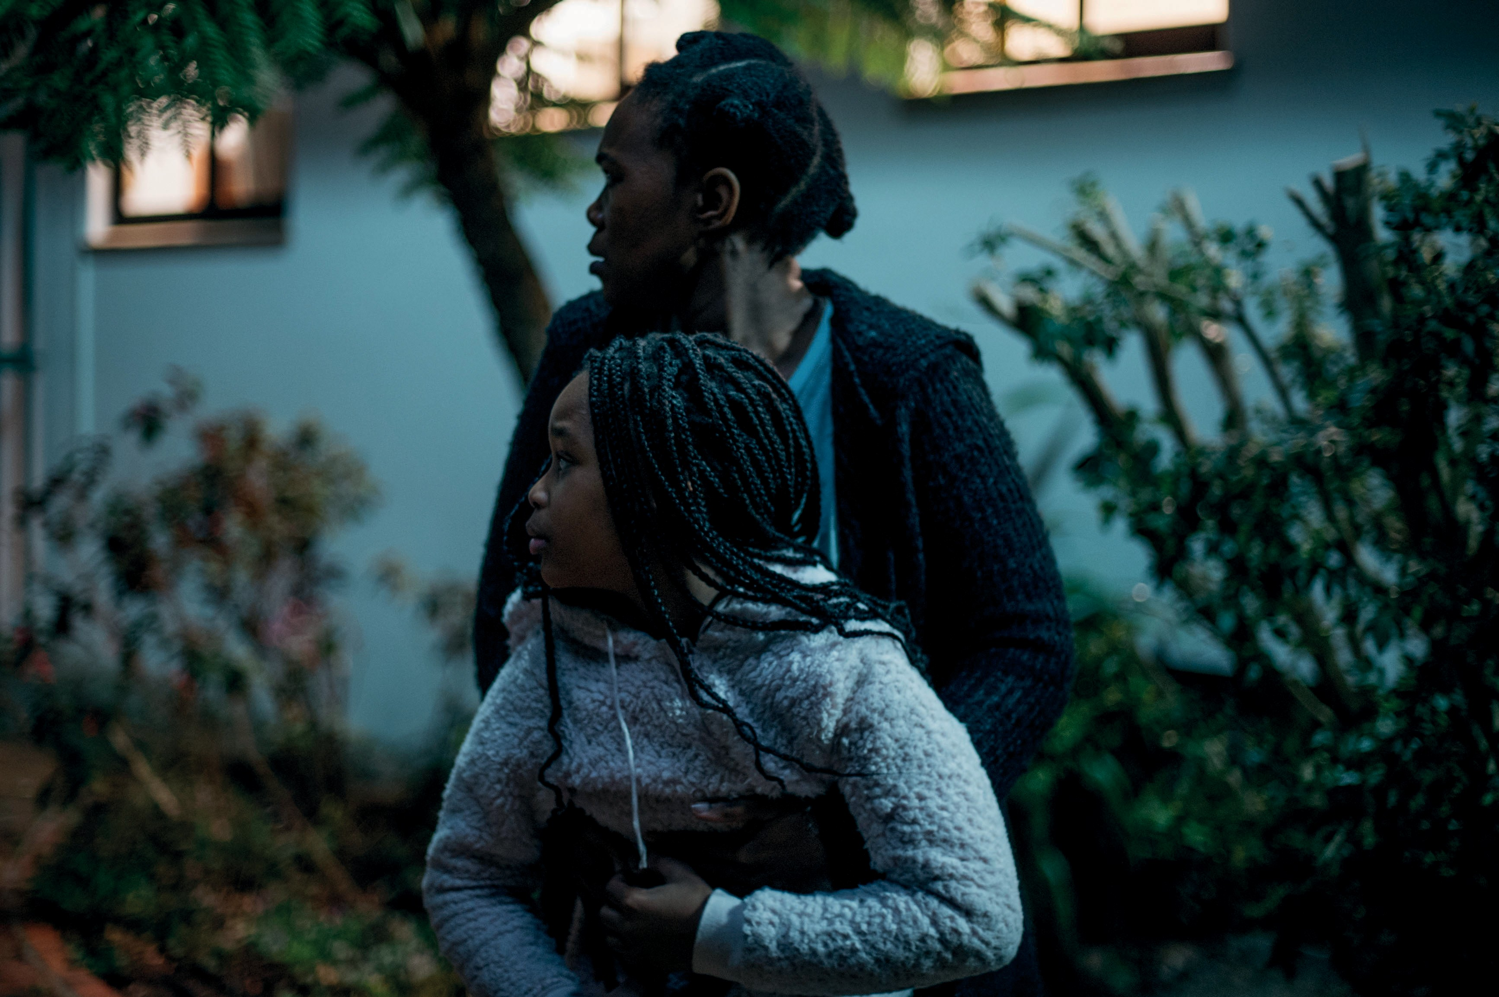

GOOD MADAM

ZA 2021
Director: Jenna Cato Bass
Cast: Chumisa Cosa, Nosipho Mtebe, Kamvalethu Jonas Raziya
For decades black housekeeper Mavis has been living with a wealthy white family in a suburb of Cape Town. When her daughter Tsidi asks her if she and Mavis’s grandchild, Winnie, can move in, the elderly woman agrees, but under one condition: that all the rules of the bedridden landlady—whom they call “Good Madam”—be follo- wed. Soon the shadows begin to grow, and Tsidi realizes that something’s fishy about this place. In GOOD MA- DAM, Jenna Cato Bass unleashes a horror thriller with a satirical, dissident edge. Its uncanny atmosphere feeds from both the specter of a supernatural menace and the threat of your garden-variety racism.

SLASH Film Festival
September 22—October 02, 2022 Filmcasino | Metro Kinokulturhaus | Gartenbaukino
www.slashfilmfestival.com

Press & Media Enquiries
Katharina Stamminger | +43 (0) 650 950 4691 | press@slashfilmfestival.com SLASH Film Festival | Festival des Fantastischen Films | www.slashfilmfestival.com
Download: Press Release | Festival Artwork | Stills: www.slashfilmfestival.com/en/press

