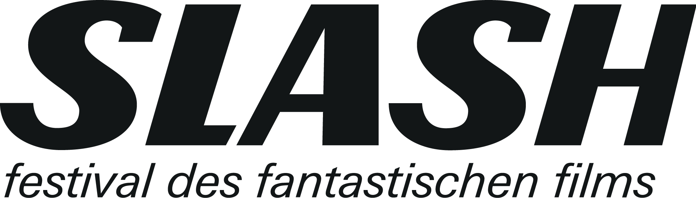

For immediate release
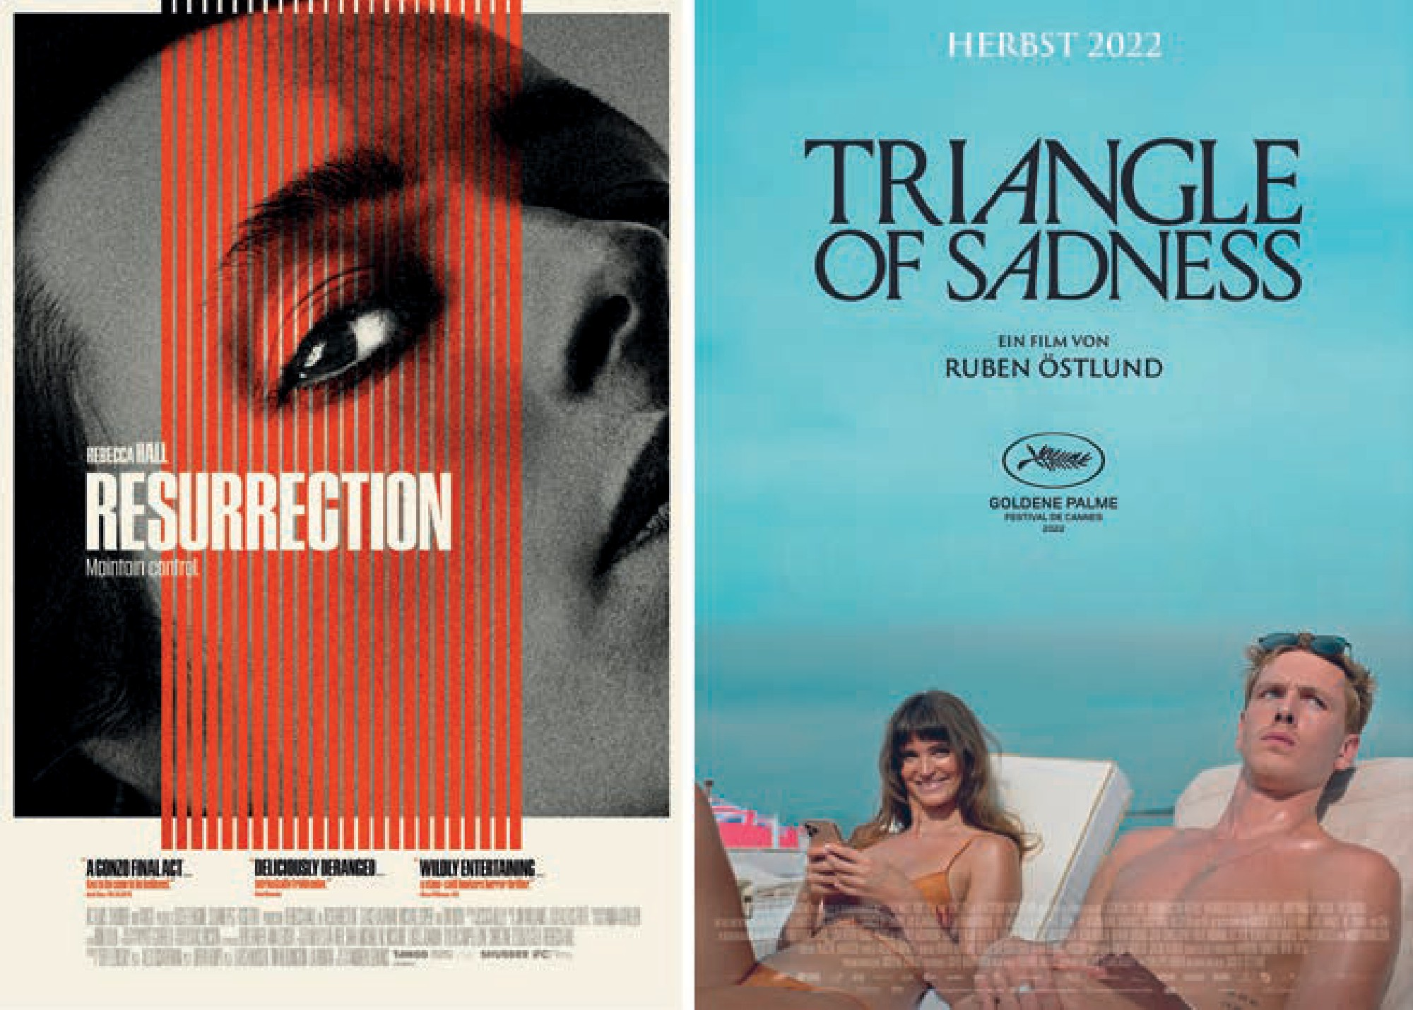

OPENING/CLOSING & FESTIVAL HITS
> Accreditation until September 15:
www.slashfilmfestival.com/en/accreditation

SLASH FILMFESTIVAL
September 22—October 02

Ticket presale starts September 09, 5pm

Program release: September 06

- Filmcasino
- Metro Kinokulturhaus
- Gartenbaukino

It’s becoming increasingly obvious we’re big fans of Noomi Rapace, as this marks the se- cond time the Swedish superstar closes out our festival—more precisely, her latest, YOU WON’T BE ALONE. Having premiered at Sundance earlier this year, the
Macedonian Australian director Goran Stolevski’s film tells a transgenerational witchcraft
story the likes of which have never been seen.

Opening this year’s SLASH will be Andrew Semans’s RESURRECTION, a dark psycho- thriller in which the horrors of the past catch up with a successful young woman (played by Rebecca Hall). Once again taking place at Gartenbaukino, the opening night will of course be accompanied by a live DJ set and plenty of good vibes.

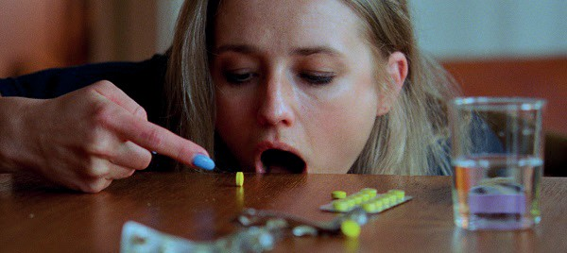
SICK OF MYSELF (2022)

We cruise from Sundance to Cannes with Ruben Östlund’s TRIANGLE OF SADNESS, the Swedish director’s second Palme d’Or winner, in which a shipwreck upends established hierarchies. Also presented in Cannes—in the category Un Certain Regard— was the Norwegian-Swedish production SICK OF MYSELF by Kristoffer Borgli, which sees the narcissism of two friends ascend to unsettling heights.

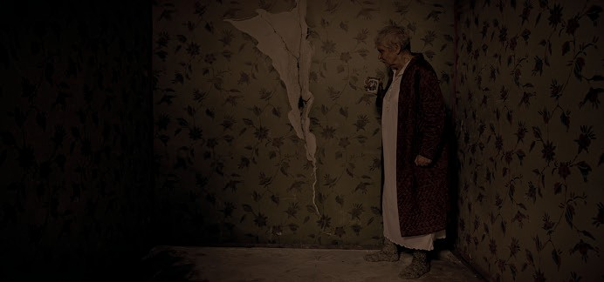
RUPTURE (2022)

FANTASTIC THINGS FROM AUSTRIA

Like every year, we are particularly delighted to give domestic offerings a stage. The supernatural decides to call a Vienna apartment its home in Paul Ertl’s RUPTURE (starring Philipp Hochmair). Marie Alice Wolfzahn’s MOTHER SUPERIOR in turn uses spooky imagery to highlight the vicinity of New Age and fascism. We are proud to host the world premieres of these two Austrian productions.

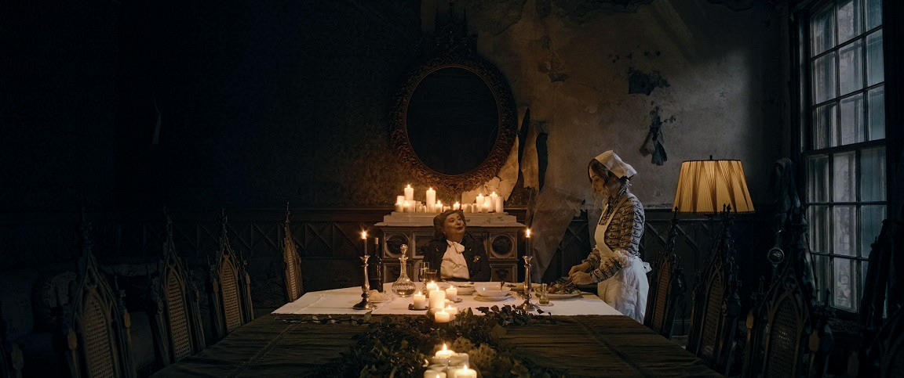
MOTHER SUPERIOR (2022)

THE KINGDOM EXODUS: EPISODE 1 & 2

Furthermore, there will be a special screening of the first two episodes of the new season of Lars von Trier’s cult hospital series from the 1990s. While a reunion with Stig Helmer, Sigrid Drusse, and the others is beyond the bounds of possibility, the curse that weighs on the Copenhagen hospital once again has some wildly bizarre scenes in store.

A GHASTLY HODGEPODGE

Along with many prestigious festival hits, more grotesque fare is not to be missed in this year’s program: Belgian director Karim Ouelhaj unleashes an utterly brutal pair of siblings in his controversial blood orgy MEGALOMANIAC. And in DEADSTREAM, director duo Vanessa and Joseph Winter send their protagonist (played by Joseph Winter himself) on a highly repulsive haunted-house tour.
> Accreditation until September 15:
www.slashfilmfestival.com/en/accreditation

SLASH Filmfestival
September 22 through October 2 Ticket presal starts September 9, 5pm Program Release: September 6
Filmcasino | Metro Kinokulturhaus | Gartenbaukino
www.slashfilmfestival.com

Press & Media Enquiries:
Katharina Stamminger | +43 (0) 650 950 4691 | press@slashfilmfestival.com
SLASH Filmfestival | Festival des Fantastischen Films | www.slashfilmfestival.com

FILM SYNOPSES

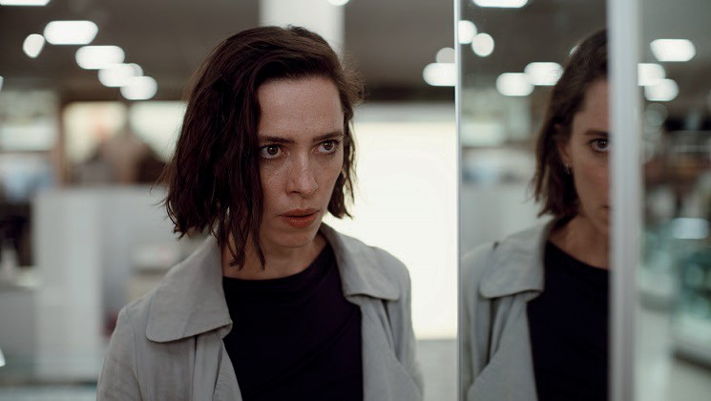

Park Circus/Universal

RESURRECTION

US 2022
Director: Andrew Semans
Cast: Rebecca Hall, Tim Roth, Grace Kaufman, Angela Carbone, Winsome Brown

Margaret is a single mom and a successful businesswoman. She seems to have all aspects of her life under control. That is, until her eye catches something—or rather, somebody—that wrenches her traumatic past into the present. Andrew Semans’s RESURRECTION nimbly plays all the right notes of classic paranoia thrillers before shifting gears into the psychological devastation of its characters, unearthing monstrous things. Rebecca Hall and Tim Roth shine in this unfathomable, controversial masterpiece that will stay with you for days and weeks.

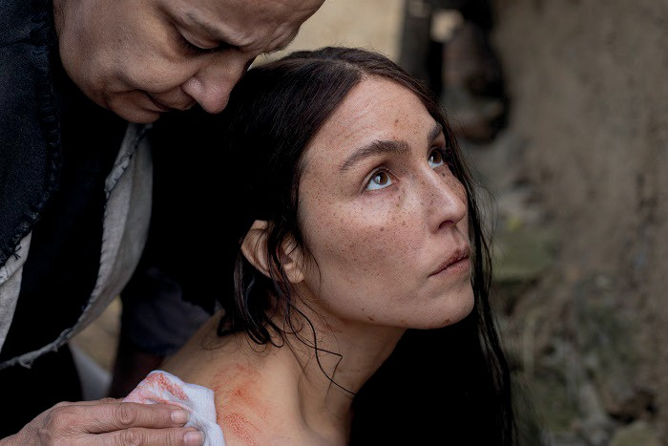

YOU WON‘T BE ALONE

AU | UK | SR 2022
Director: Goran Stolevski
Cast: Noomi Rapace, Alice Englert, Sara Klimoska, Carloto Cotta, Arta Dobroshi

A remote mountain village in nineteenth-century Macedonia. When a young woman is turned into a witch by the so-called Wolf-Eatress, she gains the ability to shift into the shape of her victims and see the world through their eyes. Goran Stolevski’s folk-horror fairy-tale, full of natural mysticism and sensory stimuli, is shot in the unconventional 1.44:1 format and presents one of the year’s most daring and best feature debuts. A narrative
torch relay, carried by lyrical inserts and moments of raw violence, the unique YOU WON‘T BE ALONE feels as if Robert Eggers and Terrence Malick were dancing the Walpurgis Night away. Wow!

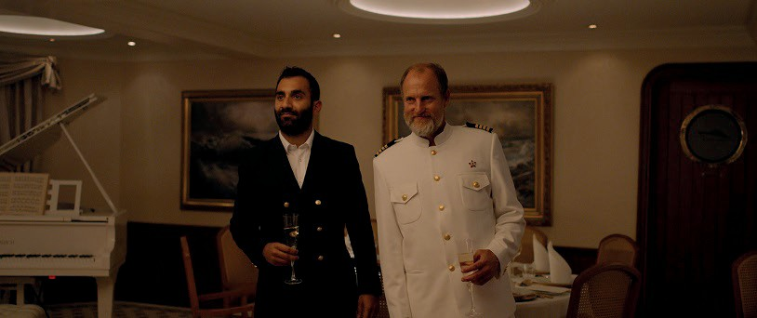
Alamode Film/Panda Film

TRIANGLE OF SADNESS

SE | FR | UK | DE | TR | GR 2022
Director: Ruben Östlund
Cast: Charibi Dean Kriek, Harris Dickinson, Woody Harrelson, Dolly De Leon, Carolina Gynning

High tides, good vibes. Well, unless it’s Swedish director Ruben Östlund sending you out to sea. For his merciless, highly entertaining satire, he received the second Palme d’Or at this year’s Cannes Film Festival. A luxury cruise teeming with the super-wealthy runs into a massive thunderstorm—and is also hijacked by pirates. The few survivors are shipwrecked on an island, where social hierarchies must be renegotiated. Biting and jarring, TRIANGLE OF SADNESS features Woody Harrelson as the Marxist captain who hosts an unforgettable dinner.

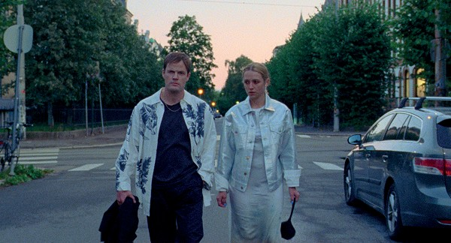

SICK OF MYSELF

NO | SE 2022
Director: Kristoffer Borgli
Cast: Kristine Kujath Thorp, Eirik Sæther, Fanny Vaager, Fredrik Stenberg Ditlev-Simonsen

As her boyfriend Thomas is about to get his big break as a contemporary artist, Signe plunges into a crisis.
To be acknowledged and recognized, she takes drastic measures. In this preposterous satire, Kristoffer Borgli unleashes the whole potential of the social media’s attention economy, cross-breeding it with a potent critique of a society increasingly interested in the surface. An excellent Kristine Kujath Thorp shines in the challenging lead of this exceedingly painful cringe fest, which premiered in Cannes this year.

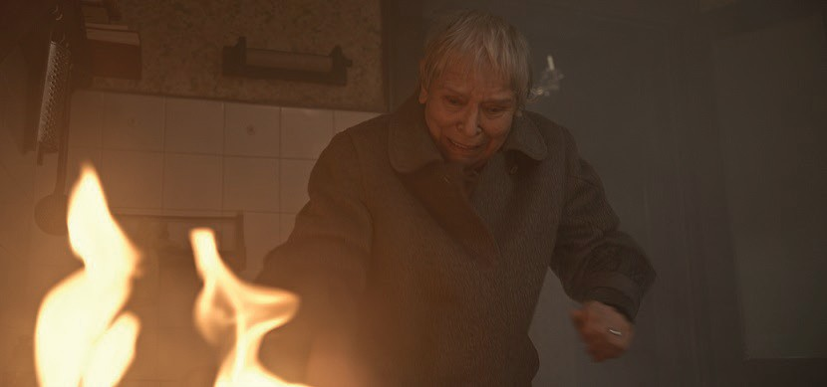

RUPTURE

AT 2022
Director: Paul Ertl
Cast: Berta Kammer, Philipp Hochmair, Markus Schleinzer, Eva Maria Marold

Frau Pospisil lives alone in her old Viennese apartment. Her son takes the old lady’s increasing forgetfulness as an opportunity to try to convince her to move to a nursing home. But then a rupture appears in a wall in her apartment, through which something enters Frau Pospisil’s world that will change her life forever. Paul Ertl’s highly efficient and beautiful RUPTURE is scary, mid-length psychological fare that metamorphoses into a debonair, original yet somewhat unsettling utopia and finally makes a forceful case for the autonomy of elderly people.

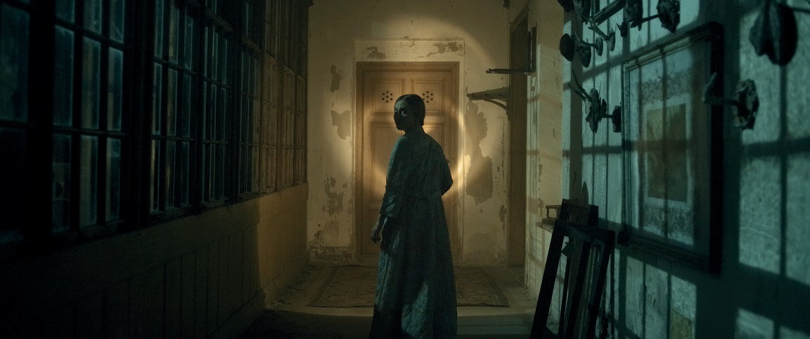

MOTHER SUPERIOR

AT 2022
Director: Marie Alice Wolfszahn
Cast: Isabella Händler, Inge Maux, Jochen Nickel, Tim Werths

It’s 1975, and Sigrun is starting her job as the caregiver of the eccentric Baroness Heidenreich in her sprawling estate, Villa Rosenkreuz. While the young woman encounters traces of her heritage there, the childless aristocrat is ready to go very far in her quest for an heiress. In her first feature, director Marie Alice Wolfzahn has crafted
a horror miniature rooted in the Gothic tradition. Floating particles from the past glide through the museum-like
premises, where fascism and New Age intersect, in order to conjure the most unholy spirits. Chilling.

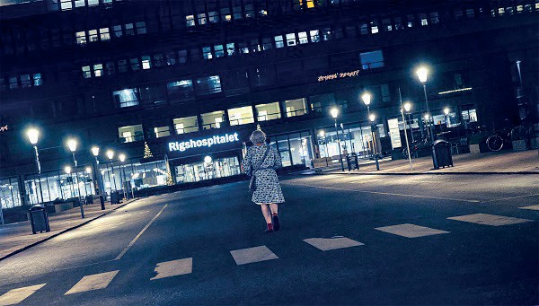

THE KINGDOM EXODUS: EPSIODE 1 & 2

DK 2022
Director: Lars von Trier
Cast: Mikael Persbrandt, Lars Mikkelsen, Nikolaj Lie Kaas, Tuva Novotny

In the mid-1990s, Danish filmmaker extraordinaire Lars von Trier gave us an incredibly bizarre series partly inspired by David Lynch’s TWIN PEAKS, titled THE KINGDOM. Set in the Copenhagen Rigshospitalet—colloquially called Riget (“The Kingdom”)—staff and patients become witnesses to supernatural events. The third and final season, EXODUS, reopens the doors to THE KINGDOM. Lars von Trier sprinkles the return to his cult series with meta- moments, acerbic zeitgeist satire, and a guest appearance by Alexander Skarsgård. In other words, legendary already!

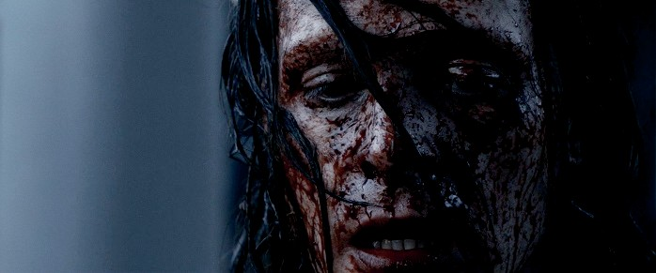

MEGALOMANIAC

BE 2022
Director: Karim Ouelhaj
Cast: Benjamin Ramon, Eline Schumacher, Hélène Moor, Karim Ouelhaj, Pierre Nisse

Between January 1996 and July 1997, the so-called Butcher of Mons murdered five women near the Belgian city of Mons. The serial killer, still on the loose to this day, is the dark epicenter of the pitch-black horror thriller MEGALOMANIAC. Director Karim Ouelhaj fantasizes about the butcher’s children, who both live in his dilapidated house. While son Félix follows in his father’s footsteps, daughter Martha becomes a victim of violence herself. MEGALOMANIAC is as bleak as it is polemical—one of the most controversial films of the festival.

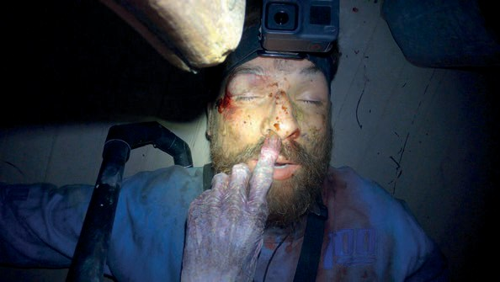

DEADSTREAM

US 2022
Directors: Joseph Winter, Vanessa Winter
Cast: Joseph Winter, Melanie Stone, Jason K. Wixom, Pat Barnett, Marty Collins, Perla Lacayo

A disgraced live streamer broadcasts his night in a purported haunted house in Utah online to win back his fan base (and his livelihood). In their feature debut, the filmmaker couple Joseph and Vanessa Winter deconstruct a typical internet bro—without forgetting to serve their audience the reason for sitting in the darkened theater: DEADSTREAM is one of the year’s best horror comedies, a playful thrill ride chock-full of fun, ingenious ideas (there’s a beef jerky cam!) and frights. Excellent!

> Accreditation until September 15:
www.slashfilmfestival.com/en/accreditation

SLASH Filmfestival
September 22—October 02
Ticket presale starts September 09, 5pm
Program Release: September 06 Filmcasino | Metro Kinokulturhaus | Gartenbaukino
www.slashfilmfestival.com

Press & Media Enquiries:
Katharina Stamminger | +43 (0) 650 950 4691 | press@slashfilmfestival.com
SLASH Filmfestival | Festival des Fantastischen Films | www.slashfilmfestival.com

