> ACCREDITATIONS until September 15:
www.slashfilmfestival.com/en/accreditation/

For immediate release

A NIGHTMARE ON QUEER STREET

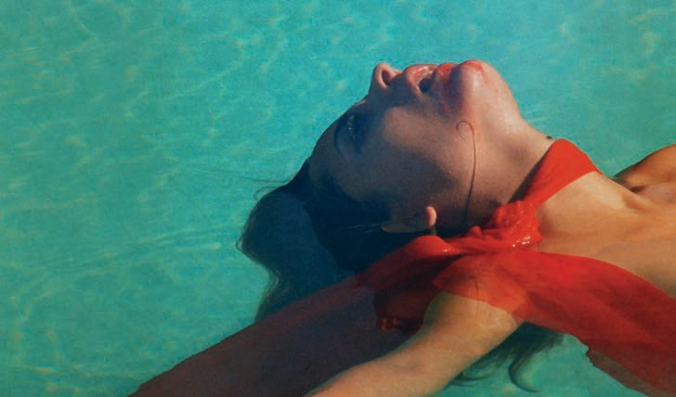

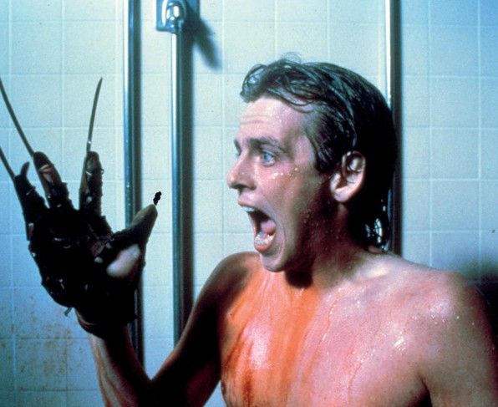
And most of them are wildly
different in their moods and whimsies, shapes and forms. Popular productions like Jack Sholder’s A NIGHTMARE ON ELM STREET PART TWO: FREDDY‘S REVENGE
or Andrew Fleming’s THE CRAFT don’t deal with queerness directly but through more or less
obvious subtexts, many of which were examined years or decades after the movies had been released.

Queer horror cinema does not exist as a category. But SLASH never shies away from a challenge and dares to take a leap with this year’s retrospective into a fierce cross-section through the history
of, well, queer horror cinema.

© 1985 WBEI

In contrast, Jess Franco’s VAMPYROS LESBOS is a movie exclusively tailored to the male gaze, having cofounded the lesbian vampire subgenre that became popular in the 1970s, while THE DESTROYING ANGEL from the same decade is highly idiosyncratic and iconoclastic gay horror porn—shot at a time when assertive portrayals of homosexuality were almost exclusively limited to fringe forms like adult and avant-garde productions. Geared to the youth market, 1980s flicks like SLEEPAWAY CAMP and FEAR NO EVIL drag psychosexual elements into subgenres like
slasher and occult horror, begging for empathy with the central, queer-coded figures only to let them disintegrate in the finale with even greater aplomb.
The last two films of the retrospective also approach the subject of queerness with great versatility. While in LET ME DIE A WOMAN sexploitation queen Doris Wishman takes a semidocumentary look at trans identity in the 1970s, WILD ZERO by Tetsuro Takeuchi tells love stories beyond gender normativity in a world populated by zombies, aliens, and the sound of revving engines.

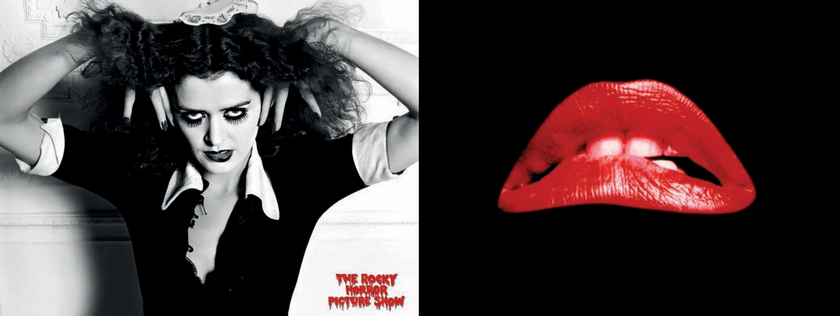

OUR GUESTS AT THE RETROSPECTIVE
Patricia Quinn in THE ROCKY HORROR PICTURE SHOW (1975)

You don’t need a fine-toothed comb to find queerness in THE ROCKY HORROR PICTURE SHOW. At the screening of Jim Sharman’s 1975 musical adaptation, we welcome no other than Magenta herself, Patricia Quinn—a joyful perk that makes even the umpteenth screening of this queer cinema classic a very special event. Also arriving from the United States is drag superstar Peaches Christ, who will not only give a series of eccentric performances around SLASH (for instance at the Volkstheater’s Rote Bar and a whacke preshow before THE ROCKY HORROR PICTURE SHOW) but also present her blood- and movie-references-soaked horror comedy ALL ABOUT EVIL. There will be a reunion with
cult director and SLASH veteran Jörg Buttgereit. Also present at the European premiere of the director’s cut of KILLER CONDOM - DIRECTOR‘S CUT (ALMOST), whose visual effects were supervised by Buttgereit, will be Martin Walz, the director of the eponymous comic book adaptation by Ralf König.
Interview requests: press@slashfilmfestival.com

Press and media enquiries:
Katharina Stamminger | +43 (0) 650 950 4691 | press@slashfilmfestival.com SLASH Filmfestival | Festival des Fantastischen Films | www.slashfilmfestival.com Download press releases, stills, festival artwork: www.slashfilmfestival.com/en/press

FILM SYNOPSES

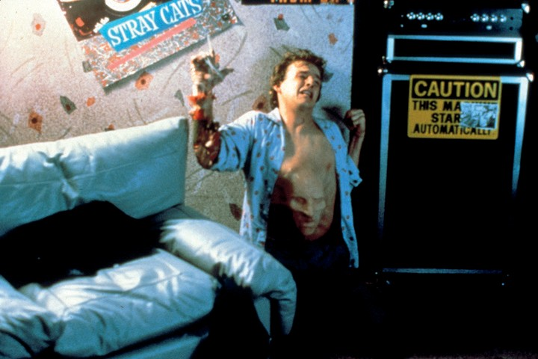
© 1985 WBEI

A NIGHTMARE ON ELM STREET PART TWO: FREDDY‘S REVENGE

US 1985
Director: Jack Sholder
Cast: Mark Patton, Robert Englund, Kim Myers, Robert Rusler, Clu Gulager

Often sold under value, this sequel to Wes Craven’s celebrated original breaks several genre rules at once. Perhaps most important, the “final girl” trope makes way for the sensitive, lovable Jesse, who must confront iconic dream demon Freddy Kruger in the last standoff. Even if director Jack Sholder purportedly didn’t realize it, the story of FREDDY’S REVENGE is the carrier material for a parade of gay subtexts (Jesse dancing to a synth-pop classic in his room! The leather bar! Spanking in the shower!), which make this highly atmospheric and often eldritch horror thriller a queer classic.

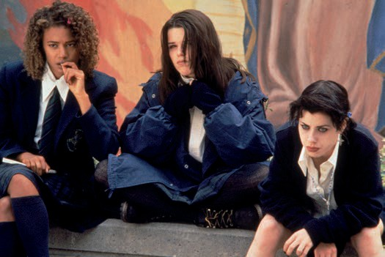
© 1996 Columbia Pictures Industries, Inc. All Rights Reserved.

THE CRAFT

US 1996
Director: Andrew Fleming
Cast: Robin Tunney, Neve Campbell, Fairuza Balk, Rachel True, Christine Taylor

Four outsiders at a high school dabble in black magic and soon take things too far. Andrew Fleming’s beloved horror hex THE CRAFT is a progressive, emancipatory fantasy on the one hand, and a moral play about sinful behavior on the other. In spite of this—or perhaps because of it—the (gay) director accomplished a blend of John- Hughesesque parallel teenage romance and wiccasploitation with considerable mid-nineties aroma (fashion! soundtrack! cast! everything!).

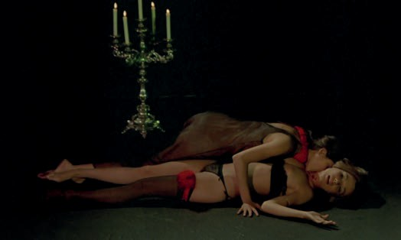

VAMPYROS LESBOS

DE | ES 1971
Director: Jesús Franco
Cast: Soledad Miranda, Ewa Strömberg, Dennis Price, Heidrun Kussin, Paul Muller

Attorney-at-law Linda falls for the charismatic countess Carody, a descendent of Dracula, who turns Linda into a vampire. Built around the mesmerizing Soledad Miranda, VAMPYROS LESBOS is a quintessential Jess Franco experience. Sucked from various literary sources, the minimalist narrative is but a peg on which to hang the surreal, often stream-of-consciousness catalog of images and sequences oscillating between meditative
contemplation and eruptive impulses. A masterpiece of horrotica, in which the (stupid) male characters are either
relegated to supporting roles or thrown out of the picture altogether.

THE DESTROYING ANGEL

US 1976
Director: Peter de Rome
Cast: Timothy Kent, Bill Eld, Philip Darden, Paul Eden, Evan de Braye, Alain Monceau

A seminary student takes some time off to indulge in sexual and drug-induced excesses. In THE DESTROYING ANGEL, exceptional British pornographer Peter de Rome uses the basic structure of Edgar Allan Poe’s autobiographically tinged doppelgänger story William Wilson as the departure point for the mental and spiritual splintering of his main character. Told through a series of increasingly menacing and surreally explicit scenes, the blend of horror topoi and gay pornography is as hot as it is unsettling, and always a unique experience.

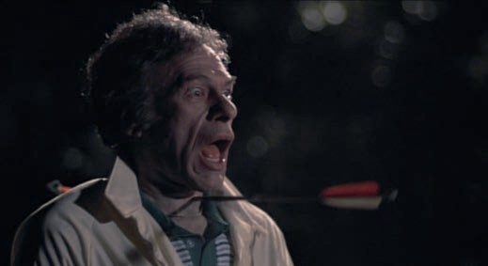

SLEEPAWAY CAMP

US 1983
Director: Robert Hiltzik
Cast: Felissa Rose, Jonathan Tiersten, Karen Fields, Christopher Collet, Mike Kellin

Shy teenager Angela spends her vacation at summer camp, where the bodies mysteriously keep piling up. SLEEPAWAY CAMP is prime-cut American slasher cinema starting out with the usual ingredients of pent-up hormones and gratuitous nudity (here predominantly of young men). But it soon twists its way heavenward into a vulgar whodunit garnished with delectable gore, only to culminate in an unforgettable finale. Both controversial and venerated as cult, director Robert Hiltzik’s only cinematic feature remains a glittering gem of slasher art.

(Print courtesy of the Academy Film Archive. Mit freundlicher Unterstützung des Filmarchiv Austria.)

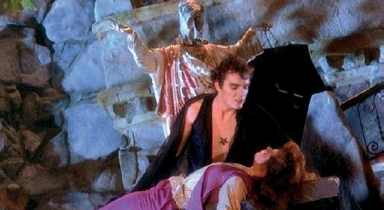

FEAR NO EVIL

US 1981
Director: Frank LaLoggia
Cast: Stefan Arngrim, Elizabeth Hoffman, Kathleen Rowe McAllen, Frank Birney, Daniel Eden

Seventeen-year-old Andrew is mercilessly bullied by his classmates. What they don’t know (yet) is that the quiet young man is the latest incarnation of Lucifer and well on his way to initiating Armageddon. Robert LaLoggia’s mostly self-financed passion project is an iridescent bastard of teen slasher and occult horror sending the erotically charged queer Antichrist into battle against archangels—among them Gabrielle, the female version
of Gabriel—and all this to a soundtrack of Ramones, Talking Heads, Sex Pistols, and Patti Smith. Pretty damn
sacred!

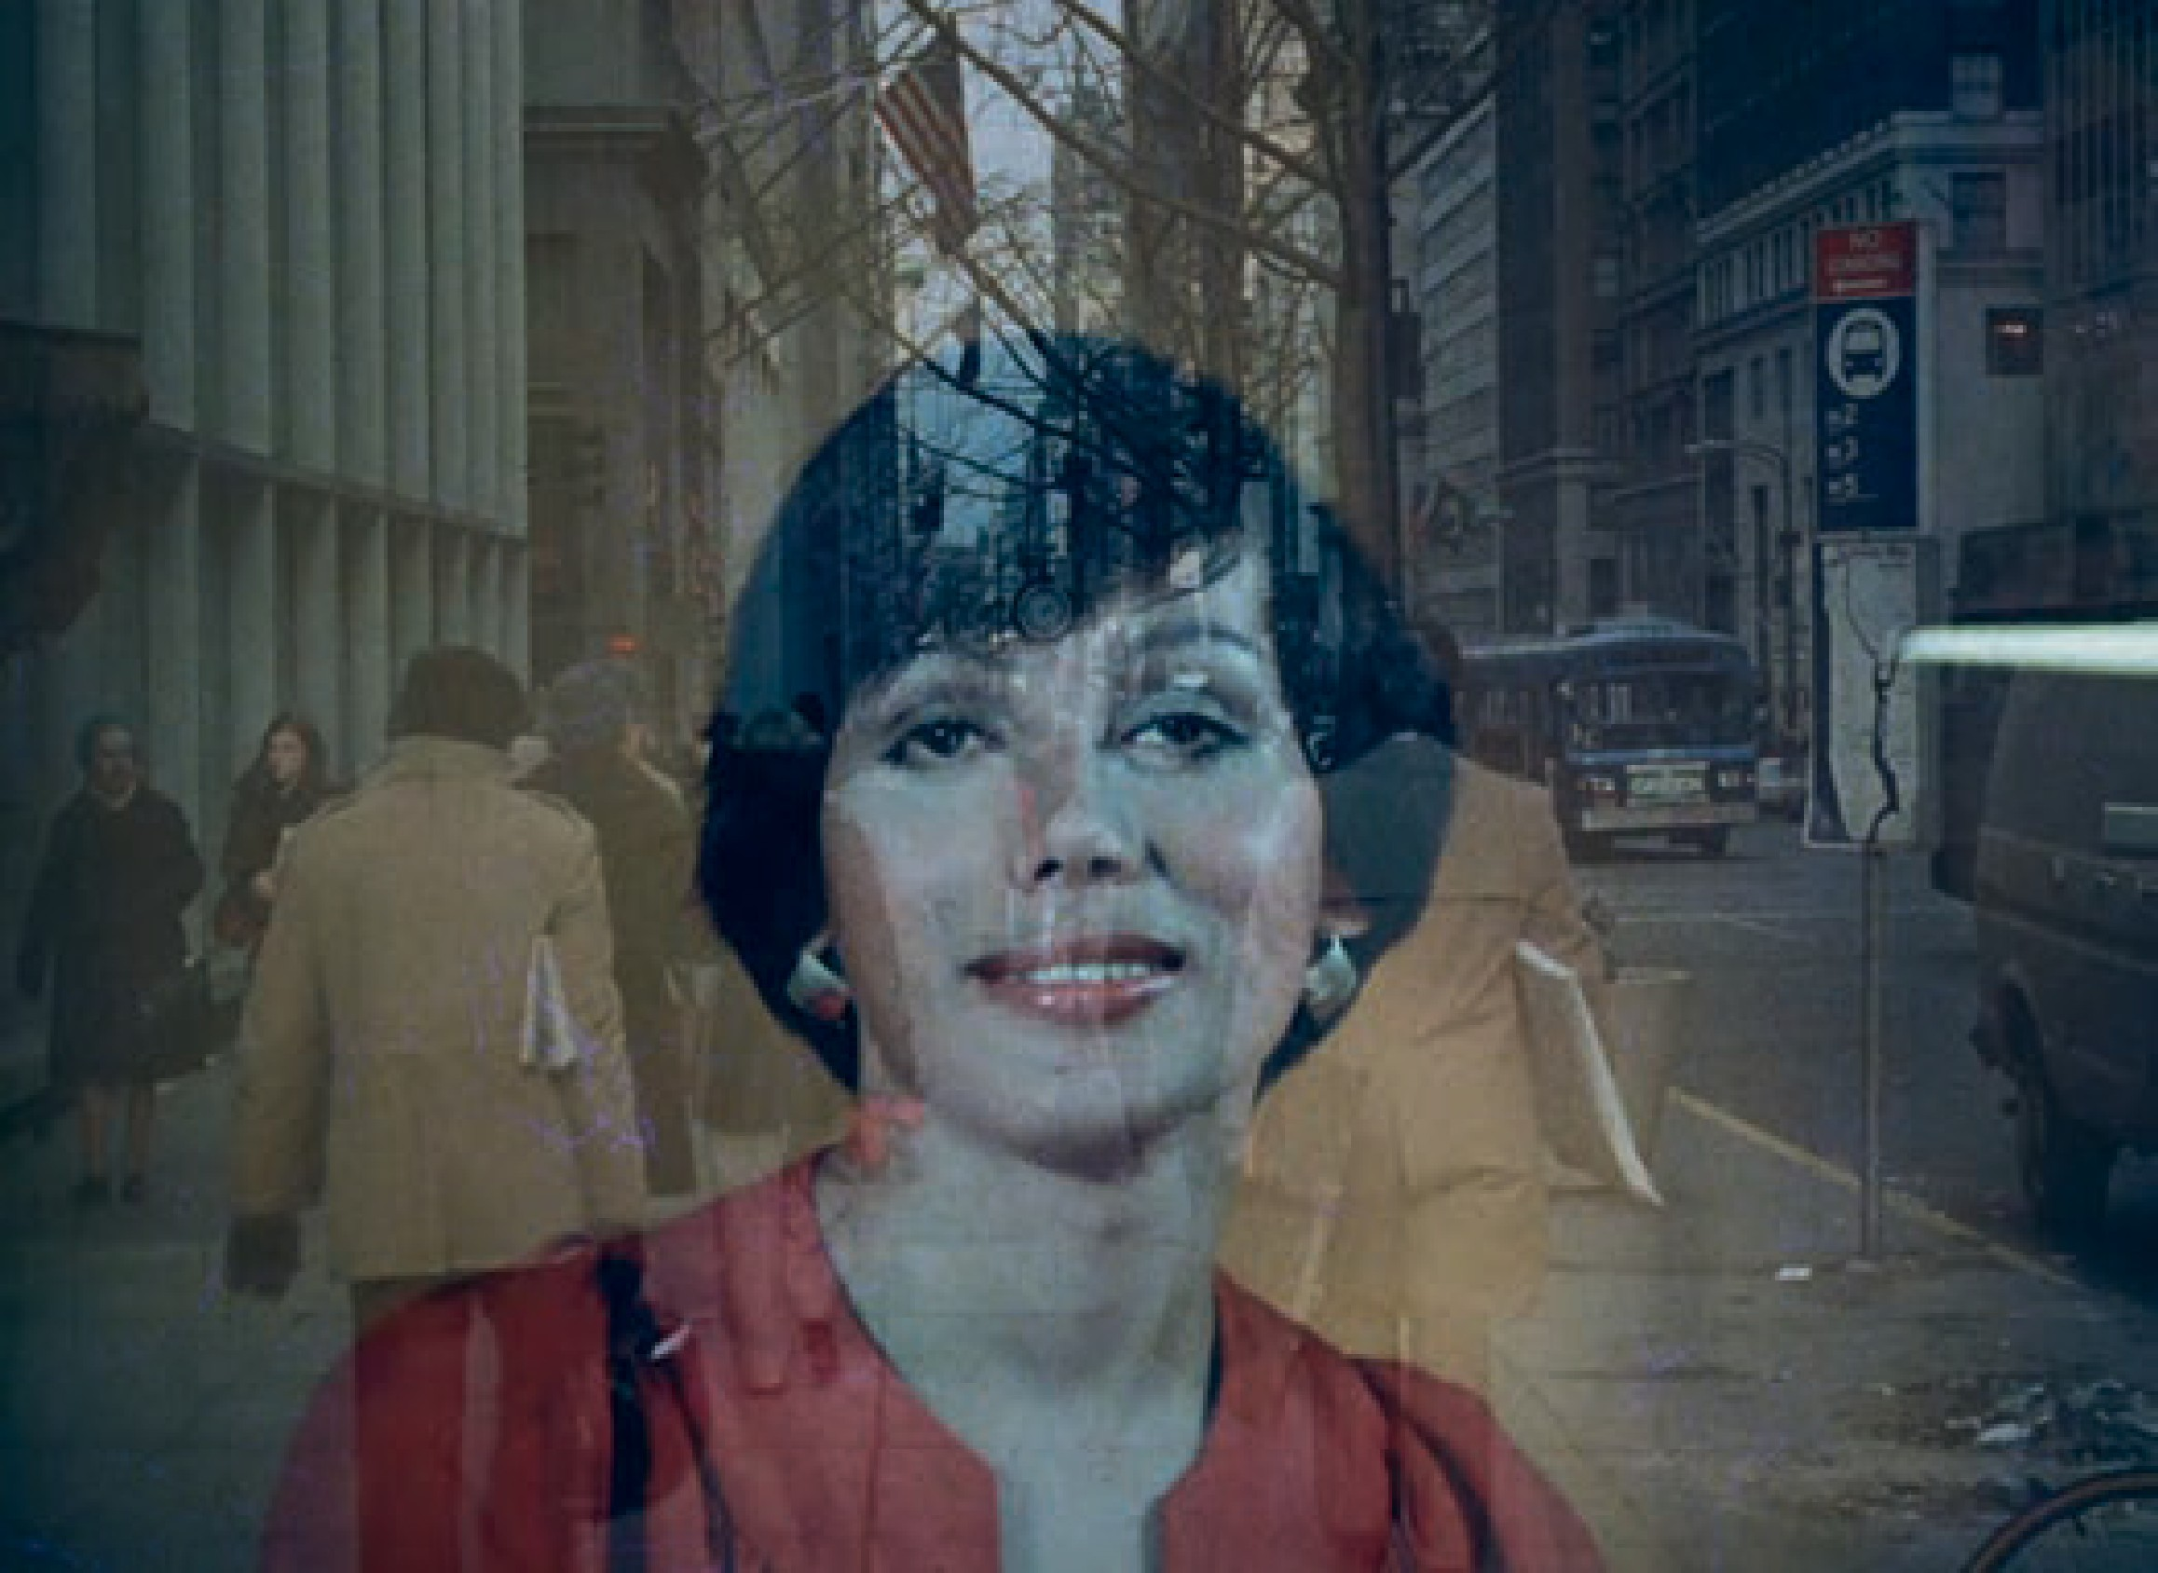

LET ME DIE A WOMAN

US 1977
Director: Doris Wishman
Cast: Deborah Harten, Leslie, Lisa Carmelle, Frank Pizzo, Harry Reems, Carol Sands

(S)exploitation pioneer Doris Wishman turns her attention to the subject of transsexuality in the only shockumentary of her career. Interviews with people affected and activists as well as a lecture by Dr. Leo Wollman, an authority
on the subject at the time, are peppered with soft sex scenes, close-ups of genitals, and footage of a gender reassignment operation—which gave the movie its notoriety—in the style of sensationalist sex-ed films. LET ME DIE A WOMAN is real and pseudo, educational and reactionary, reprehensible and bold and, at any rate, unforgettable.

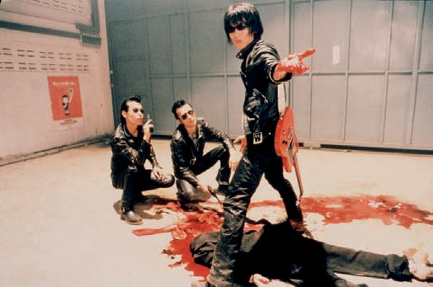

WILD ZERO

JP 1999
Director: Tetsuro Takeuchi
Cast: Seji, Bass Wolf, Drum Wolf, Masashi Endē, Kwancharu Shitichai, Nakajo Haruka

Perfectly pomaded pompadours crown pitch-black leather outfits. Guitar Wolf is a Japanese rock ‘n’ roll band who in their hyperenergetic brain grinder of a cult movie WILD ZERO take their biggest fan Ace, his new flame Tobio, and other deviants to fight a zombie invasion AND an alien invasion. Director Tetsuro Takeuchi puts the pedal all the way to the metal on this one. Heads burst, plectrums kill, and eyes shoot deadly rays of energy. Yet there’s time for tenderness. In the words of Guitar Wolf: “Love has no borders, nationalities or genders.”

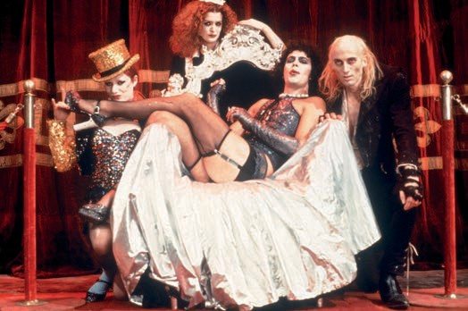
© 1975 Twentieth Century Fox Film Corporation. All rights reserved.

THE ROCKY HORROR PICTURE SHOW

UK | US 1975
Director: Jim Sharman
Cast: Tim Curry, Patricia Quinn, Susan Sarandon, Richard O‘Brien, Nell Campbell

It might be the most popular convergence of queer and horror culture, rendered in exemplary ultracamp aesthetics and thoroughly pervaded by Tim Curry’s masterful portrayal of Frank-N-Furter, the “sweet transvestite from Transsexual Transylvania,” who lures a meat-and-potatoes couple stranded in his castle in the sky into committing various acts of sweet transgression. THE ROCKY HORROR PICTURE SHOW is the apotheosis of the midnight movie and musical feat, and at once a eulogy to all “Creatures of the Night” with a subsequent call to throw off the shackles of middle-class morality. Or, in the immortal words of Dr Furter: “Don’t dream it, be it.”

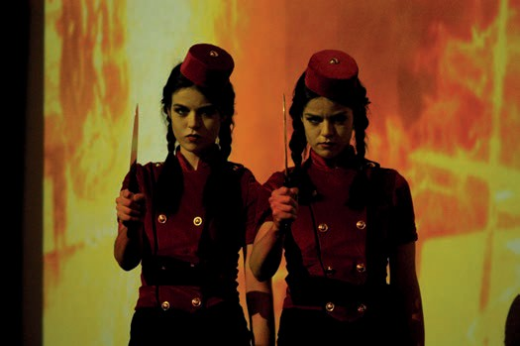

ALL ABOUT EVIL

US 2010
Director: Joshua Grannell
Cast: Natasha Lyonne, Thomas Dekker, Cassandra Peterson, Jack Donner, Mink Stole

The title alone is a reference to a definitive silver-screen classic, and Joshua Grannell’s feature debut doesn’t make any secret of his unconditional love for (horror) cinema: Natasha Lyonne inherits an old movie theater and shoots splatter miniatures to draw an audience. What nobody suspects: The kills are all real. Lovingly handcrafted and adorned with subcultural icons from John Waters staple Mink Stole and Cassandra “Elvira” Peterson to Grannell’s drag queen persona Peaches Christ, ALL ABOUT EVIL is a B-movie gem that’s at once heartwarming and blood-drenched.

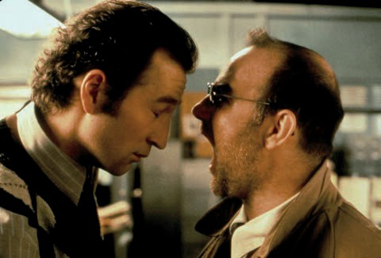

KILLER KONDOM - DIRECTOR‘S CUT (ALMOST)

DE | CH 1996
Director: Martin Walz
Cast: Udo Samel, Peter Lohmeyer, Iris Berben, Heribert Sasse, Hella von Sinnen, Sophie Rois

This souped-up pulp fiction about a gay cop who hunts a sharp-toothed condom through the seedy underbelly of New York City must be one of the whackiest—i.e., most entertaining, i.e., best—German movies of the 1990s. Few people agreed when it came out, probably not least because the adaptation of two graphic novels by Ralf
König swaggers our way with unapologetic queerness unlike any other movie of its time. Need more convincing? Jörg Buttgereit was in charge of special effects; H.R. Giger (!!!) designed the killer condom.

> ACCREDITATIONS until September 15:
www.slashfilmfestival.com/en/accreditation/

SLASH Film Festival September 22—October 02, 2022
Filmcasino | Metro Kinokulturhaus | Gartenbaukino www.slashfilmfestival.com

Press and media enquiries:
Katharina Stamminger | +43 (0) 650 950 4691 | press@slashfilmfestival.com SLASH Filmfestival | Festival des Fantastischen Films | www.slashfilmfestival.com Download press releases, stills, festival artwork: www.slashfilmfestival.com/en/press

