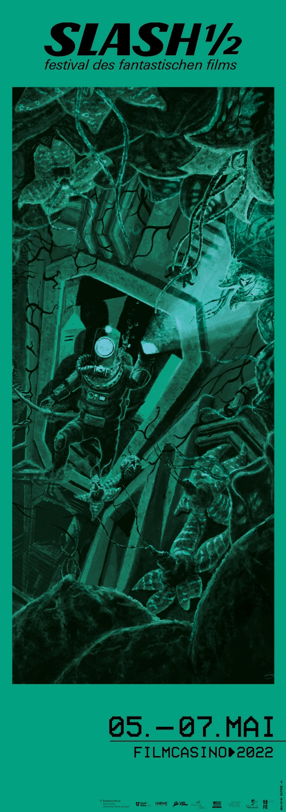
For immediate release

SLASH ½ ONCE AGAIN PAINTS VIENNA’S FILMCASINO RED
May 5–7, 2022, Filmcasino
First Film Highlights & Festival Artwork

This year’s SLASH ½ features films once again showcasing the dazzling range fantastic cinema has to offer. What these eleven movies share is the core theme of resistance. Already an act of resistance in and of itself—against the mainstream, against good taste, against all that is established and agreeable—fantastic cinema is uniquely suited to illustrate the many facets of revolt in our society. The films of this year’s SLASH ½ often revolve around self-empowerment and protest but also revenge and vigilante justice.

After decades of neglect and complacency, nature has also come to collect its dues from us for abusing and exploiting it. Now is its time to strike back with full force, in the form of devastating disasters. Nature’s grim omens—higher temperatures and ever-rising sea levels—have inspired this year’s festival artwork by graphic-design duo Elias Fleischer and Franz Mühringer, of HYPHE agency: While the water is still at a simmer and the heat still somewhat bearable, things surely will not stay that way very long . . .

SLASH ½ is once again pleased to cooperate with the Crossing Europe Film Festival Linz, whose Night Shift segment is curated by SLASH founder Markus Keuschnigg. The first film from this segment shown at SLASH ½ will be HATCHING, a modern interpretation of the body horror genre by Finnish director Hanna Bergholm. Opening SLASH ½ will be EVERYTHING EVERYWHERE ALL AT ONCE by Dan Kwan und Daniel Scheinert, which was the Opening Night Film at Austin’s renowned SXSW festival in 2022. Known for mind-boggling scenes, the Daniels had previously shown their grotesque tragicomedy SWISS ARMY MAN at the 2016 SLASH Film Festival—to great success. The two next films also promise exciting reunions with old acquaintances: Director Kirill Sokolov, whose pitch-black crime comedy NO LOOKING BACK we’re showing at SLASH ½, paid us a personal visit in 2019. And Dario Argento, the grand seigneur of giallo, whose latest work DARK GLASSES recently had its world premiere at the Berlin Film Festival and will now grace the Filmcasino screen for SLASH ½, was our special guest in 2014.

THE NEXT BATCH OF FILM HIGHLIGHTS IS COMING ON APRIL 14, 2022!

>> Ticket presale starts April 25, 2022. <<
SLASH ½ 2022:
May 5 to 7 2022, Filmcasino

SLASH FESTIVAL 2022:
September 22 to October 2 2022

Press enquiries:
Katharina Stamminger | +43 (0) 650 9504691 | press@slashfilmfestival.com
SLASH Film Festival | Festival des Fantastischen Films |
www.slashfilmfestival.com/
Download film stills & festival artwork: www.slashfilmfestival.com/en/press/

FIRST FILM HIGHLIGHTS SLASH ½ 2022

SLASH ½ FESTIVAL: FIRST FILM HIGHLIGHTS

hosted by FM4:
EVERYTHING EVERYWHERE ALL AT ONCE
USA 2022
Directors: Dan Kwan, Daniel Scheinert
Starring: Michelle Yeoh, Stephanie Hsu, Ke Huy Quan, James Hong, Jamie Lee Curtis

Once you’ve entered the cerebral maze of “Daniels,” it’s hard to find an exit—not that you’d want to, anyway. Six years after SWISS ARMY MAN, starring Harry Potter as an ever-flatulent corpse, they now send the legendary Michelle Yeoh into their emotionally tinged, totally whacked-out cinematic universe. A disillusioned laundromat owner in trouble with the IRS, Yeoh’s character suddenly faces the task to save not only our planet but a multiverse of dimensions. The Daniels put on a firework of kooky ideas exploding into existential surrealism with a profoundly human touch. Art with a capital A!

NO LOOKING BACK
Russia 2021
Director: Kirill Sokolov
Starring: Anna Mikhalkova, Viktoriya Korotkova, Sofya Krugova, Aleksandr Yatsenko

After four years in the can, Olya returns home, determined to start over with her ten-year-old daughter Masha. But a grandmother prone to violent outbursts isn’t willing to let the girl leave. Masha and Olya run away, with the matriarch close on their trail. Three years after his successful WHY DON’T YOU JUST DIE?, Kirill Sokolov wows audiences with this wild mix of family grotesquerie, splatstick comedy, and road movie. NO LOOKING BACK is packed with brilliant ideas and moments, but also lingers in our memory for its intergenerational portraits of three iron-clad women. Plus, Masha is hands down the coolest celluloid kid of all time!

DARK GLASSES
Italy/France 2022
Director: Dario Argento
Starring: Asia Argento, Ilenia Pastorelli, Andrea Zhang

On the run from a serial killer, the high-class escort Diana crashes her car and loses her eyesight. While she slowly learns to live her life as a blind person, she befriends the Chinese boy Chin, whose parents died in the same accident. But the killer still has some unfinished business and is dogging her steps. Il maestro è tornato! A full decade after his last big-screen adventure, legendary director Dario Argento returns to the genre that made his career. DARK GLASSES is a sleek giallo, an unpretentious late work imbued with subtle madness and garnished with luscious splatter effects.

in cooperation with CROSSING EUROPE:

HATCHING
Finland/Sweden 2022
Director: Hanna Bergholm
Starring: Siiri Solalinna, Sophia Heikkilä, Jani Volanen, Reino Nordin

Here’s a rule of thumb for horror movies (but not only): The more beautiful the facade, the more broken the interior. HATCHING tells the story of a (naturally) blond Finnish poster family who showcase their suburban existence, which they have honed to perfection, for the world to see in a video blog. Only the pubescent daughter, Tinja, can’t quite adjust to the forced joy of their wholesome existence: One day, she finds an egg in the forest and promptly plans to hatch it at home. What finally cracks the shell seems to share a close connection with the girl and starts to shake the foundations of the idyllic life once and for all. Creature feature meets body horror in Hanna Bergholm’s debut feature: adorable!

***

