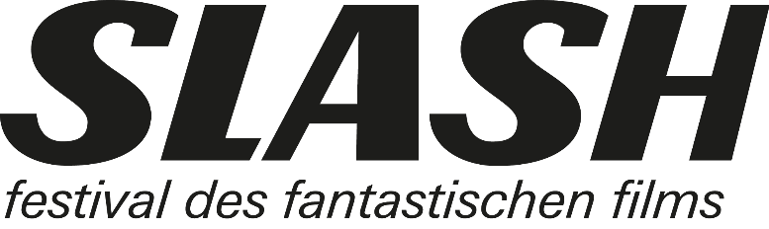

For immediate release

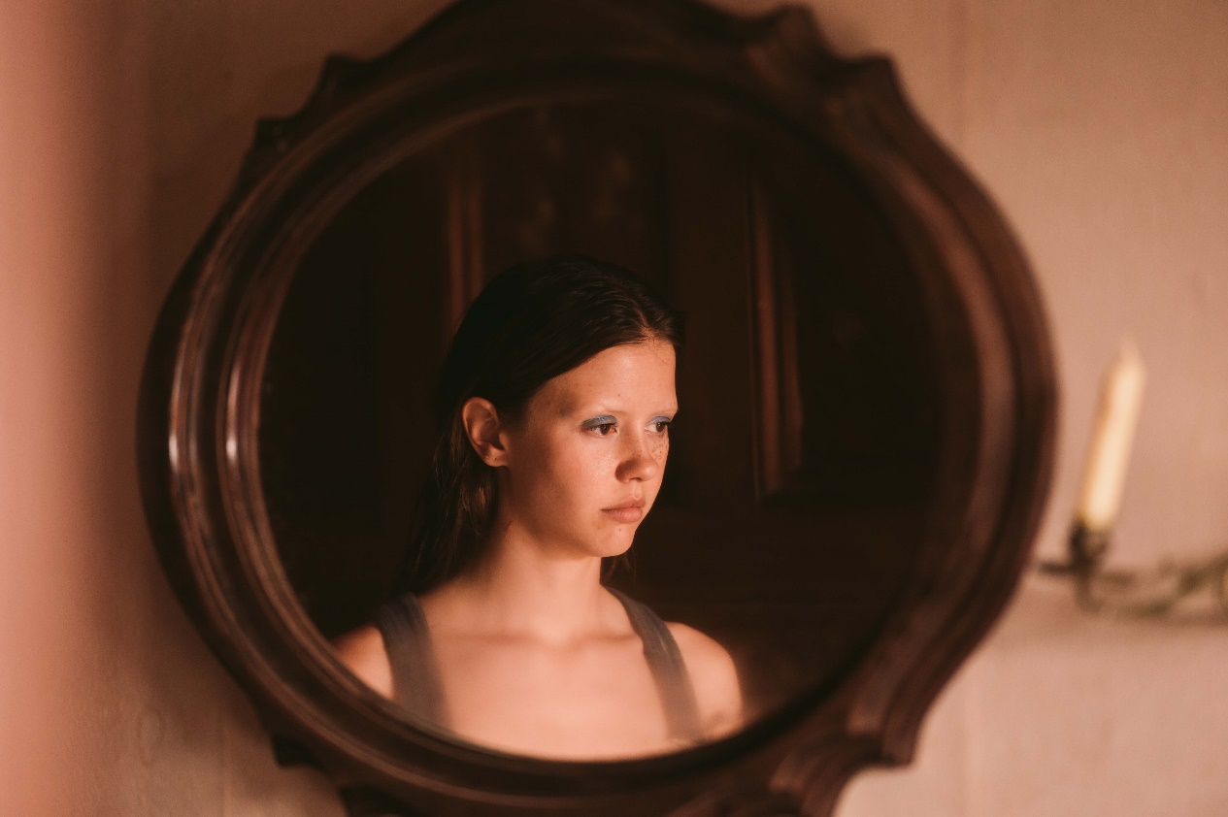
SLASH ½ FILM FESTIVAL: ALL FILMS AND DATES
May 5–7, 2022, Filmcasino

Mia Goth in Ti Wests X
(Photo Credit: Christopher Moss)

Resistance, empowerment, upheaval: This is the motto of this year’s SLASH ½ Film Festival. The last film to be added to our lineup fits this mold perfectly, and we’d be remiss to keep it from you any longer: MONA LISA AND THE BLOOD MOON is a somewhat quieter affair than director Ana Lily Amirpour’s previous feature THE BAD BATCH, but to no detriment to its bizarre whimsy. Her “adventure fairy-tale” premiered at the Venice Film Festival in 2021 and wowed audiences not only with its deeply bizarre yet heartwarming story of a misfit but also its 1980s and ’90s neon look.
Together with other highlights like Ti West’s sex- and blood-drenched slasher gem X, Dan Kwan and Daniel Scheinert’s long-awaited tour de force EVERYTHING EVERYWHERE ALL AT ONCE, giallo master Dario Argento’s unpretentious late work DARK GLASSES, and HATCHING, a ninety-minute family therapy session from hell, SLASH ½ promises to deliver three days full of thrills, fun, and goosebumps.

Rounding off the program are KUNG FU ZOHRA, an excellent blend of martial arts and marital drama, INEXORABLE, Fabrice du Welz’s usurper thriller with sexual undertones, the darkly comical road movie NO LOOKING BACK with splatstick elements galore, the European superhero blockbuster FREAKS OUT starring Franz Rogowski, UPURGA, a somber piece of Baltic folklore, and the horror satire SOME LIKE IT RARE, which takes the meaning of a vegan diet to a whole new level.
The entire program of the SLASH ½ Film Festival
is now available at www.slashfilmfestival.com.
Ticket presale starts on April 25, 5pm
exclusively via www.slashfilmfestival.com.

Siiri Solalinna in Hanna Bergholms HATCHING
(Photo Credit: Andrejs Strokins)

Katharina Stamminger | +43 (0) 650 9504691 | press@slashfilmfestival.com
SLASH Film Festival | Festival des Fantastischen Films |
www.slashfilmfestival.com
Download film stills & festival artwork: www.slashfilmfestival.com/en/press

ALL FILMS UND DATES
Thursday May 5: 18:00 KUNG FU ZOHRA | 20:30 EVERYTHING EVERYWHERE ALL AT ONCE | 23:00 UPURGA
Friday May 6: 18:00 INEXORABLE | 20:30 MONA LISA AND THE BLOOD MOON |
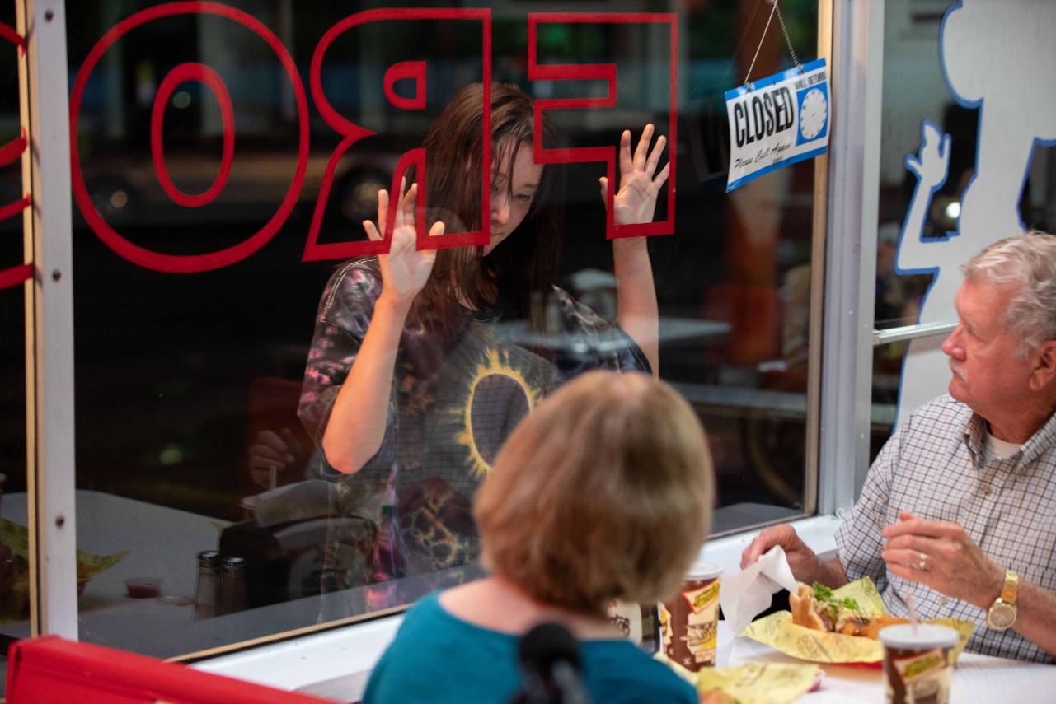
23:00 DARK GLASSES | 01:00 (night FR/SA) NO LOOKING BACK
Saturday May 7:
15:30 FREAKS OUT | 18:00 SOME LIKE IT RARE | 20:30 X 23:00 HATCHING

hosted by thegap:
MONA LISA AND THE BLOOD MOON
USA 2021
R: Ana Lily Amirpour
Mit: Ed Skrein, Kate Hudson, Jeon Jong-seo, Craig Robinson, Michael Carollo
During the intro, you hear a voice calling for “Mona Lisa,” almost as if it wanted to summon the enigmatic main character of this wild, idiosyncratic New Orleans fantasy. Mona Lisa, a North Korean woman with telekinetic abilities, has just escaped from a high-security mental asylum. Single-parent stripper Bonnie (a superb Kate Hudson) swiftly takes her under her wing and exploits her shamelessly, until Mona Lisa elopes with Bonnie’s son Charlie. Equal parts cuckoo bananas and sweet as honey, MONA LISA AND THE BLOOD MOON keeps insisting that something like hope and human warmth can—and indeed must—exist in this cold, dirty world. (Watch film clip on YouTube)

